JAVA LAB PROGRAM 3

import java.util.*;  
class Book  
{

private String name;

private String author;

private double price;

private int num_pages;

public Book(String name,String author,double price,int num_pages)

{

[this.name](http://this.name/)=name;

this.author=author;

this.price=price;

this.num_pages=num_pages;  
}  
  
public String getName()  
{

return name;  
}  
public String getAuthor()  
{

return author;  
}  
public double getPrice()  
{

return price;  
}  
public int getNum_pages()  
{

return num_pages;  
}  
  
public void setName()  
{

[this.name](http://this.name/)=name;  
}  
public void setAuthor()  
{

this.author=author;  
}  
public void setPrice()  
{

this.price=price;  
}  
public void setNum_pages()  
{

this.num_pages=num_pages;  
}  
  
@Override  
public String toString()  
{

return "(Book name:" + name + "\nAuthor:" + author + "\nPrice:" + price +

"\nNumber of pages:" + num_pages+")";  
}

}  
public class BookStore{

public static void main(String[] args)

{

Scanner input=new Scanner(System.in);

System.out.println("Enter number of books: ");

int n=input.nextInt();

input.nextLine();

Book[] books=new Book[n];

for(int i=0;i<n;i++)

{

System.out.println("Enter Book Name: ");

String name=input.nextLine();

System.out.println("Enter Author name: ");

String author=input.nextLine();

System.out.println("Enter Price: ");

double price=input.nextDouble();

System.out.println("Enter No. of Pages: ");

int num_pages=input.nextInt();

books[i]=new Book(name,author,price,num_pages);  
}  
  
for(int i=0;i<books.length;i++)  
{

System.out.println(books[i]);  
}

}  
}

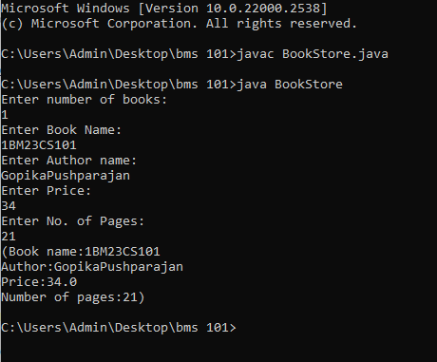OUTPUT